Salesforce.com
- Salesforce (SFDC) was officially launched in 1999 with the vision of becoming a global leader in on-demand CRM.
- It was founded by Marc Benioff and has grown to become the world’s number one on-demand CRM platform.
- The Force.com platform helps reduce development costs by enabling businesses to build and deploy applications quickly.
- Through AppExchange, users can buy ready-made applications or sell their own custom-built solutions.
- Salesforce operates entirely on cloud computing technology, meaning no software installation or hardware setup is required.
- As a Software as a Service (SaaS) solution, users do not need to manage servers or maintain infrastructure.
- One of the key advantages of Salesforce is its regular upgrades—three major releases each year: Winter, Spring, and Summer.
- Overall, Salesforce offers a comprehensive suite of CRM products that work together to help organizations operate more efficiently and increase profitability, supporting multiple functional areas across a company.

CRM
- CRM is a model used to manage an organization’s interactions with customers and prospects through channels such as phone calls, emails, meetings, and social media.
- It supports key business functions including Sales, Marketing, and Customer Support.
- Salesforce CRM is a collection of integrated applications and business processes that enable companies to manage customer data, activities, and communications in a centralized system.
CRM stands for Customer Relationship Management, and its primary goals include:
- Increasing sales revenue
- Improving visibility and collaboration between departments
- Reducing operating costs
- Streamlining business processes

Salesforce Architecture

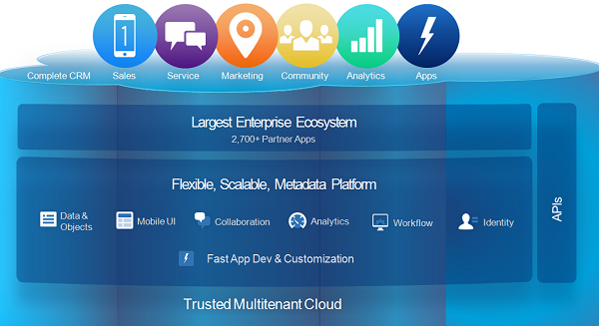

- Salesforce architecture is designed in multiple layers to ensure scalability, security, customization, and integration.
- Salesforce works on a Trusted Multitenant Cloud Architecture.
This means multiple customers (tenants) share the same physical infrastructure, but their data is logically separated and highly secure.
This model ensures cost efficiency, high availability, and strong data security.
- Salesforce uses a Metadata-Driven Architecture.
Instead of hard coding customizations, everything like objects, fields, workflows, and UI changes are stored as metadata.
This makes the platform highly scalable and allows easy customization without affecting the core application.
- Salesforce has a strong Enterprise Ecosystem.
Through AppExchange and partner applications, businesses can extend functionality by installing third-party or custom-built apps.
- Salesforce provides complete CRM functionality, including Sales, Service, Marketing, automation tools, analytics, and app development capabilities — all in one platform.
- Salesforce offers a powerful set of APIs such as REST API, SOAP API, Bulk API, and Streaming API.
These APIs allow integration with external systems and support mobile and web application development.

MVC Architecture in Salesforce

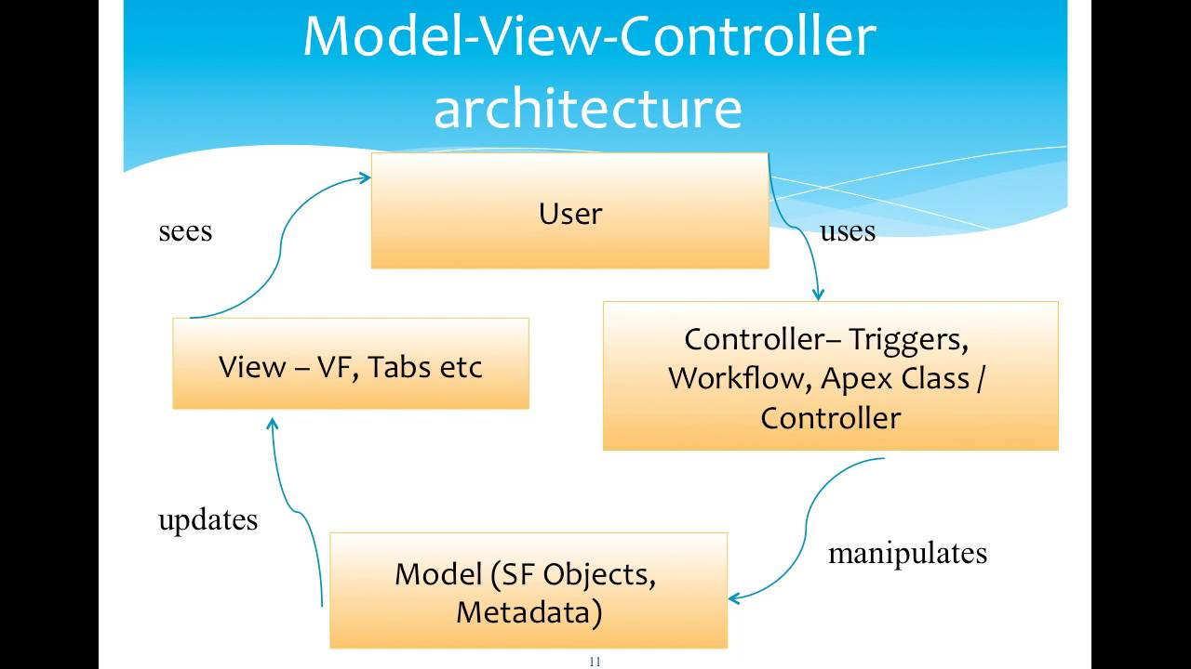

MVC (Model-View-Controller) is a software architecture pattern that separates an application into three layers: Model, View, and Controller.
This separation helps in better design, easier maintenance, and improved scalability.
In Salesforce, MVC architecture is implemented as follows:
Model (Database Layer)
- The Model layer represents the data and database structure in Salesforce.
- Includes Objects, Fields, and Relationships
- Data is stored in sObjects (Standard Objects and Custom Objects)
- Example: Account, Contact, Opportunity, and Custom Objects
View (User Interface Layer)
The View layer represents how data is displayed to the users.
Includes:
- Visualforce Pages
- Page Layouts
- Tabs
- Lightning Pages
Visualforce pages display data and interact with controllers.

Controller (Business Logic Layer)
The Controller layer handles business logic and user actions.
Includes:
- Apex Classes
- Apex Triggers
- Workflows and Automation
- Standard Controllers
- Custom Controllers
Controllers process user requests and update data in the Model.
Benefits of MVC Architecture
- Separation of Concerns: Each layer works independently, making development easier.
- Easy Maintenance: Changes in the UI do not affect the database or business logic.
- Reusability: Multiple views can use the same business logic.
- Faster Development: Different developers can work on Model, View, and Controller simultaneously.
- Reliability: Changes in one layer do not impact other layers.

Types of Environments:
- An Environment in Salesforce is an instance of the Force.com platform, also called an Organization (Org).
- It allows users to develop, test, deploy, and run applications based on the configuration of that environment.
There are three main types of environments:
- Production Environment
- Development Environment
- Testing Environment
Production Environment
The Production Environment is the live environment where actual business users work with real-time business data.
Features
- Contains live business data
- Used by end users
- Business-critical environment
- Final deployment happens here

Development Environment
- The Development Environment is used to build and test applications without affecting production data.
- It contains test data only, not business-critical data.
Development can be done:
- Using Browser
- Using VS Code / IDE
1. Developer Edition (DE)
Developer Edition is a free Salesforce environment used for learning and development.
Features
- Free signup
- Fully functional platform
- Limited storage
- Limited users
2. Sandbox Environment
A Sandbox is a copy of the Production environment used for development, testing, and training without affecting live business data.
Salesforce provides four types of Sandbox environments:
- Developer Sandbox
- Developer Pro Sandbox
- Partial Copy Sandbox
- Full Sandbox
Developer Sandbox
A Developer Sandbox is mainly used by individual developers for coding and unit testing.
Features
- Copies metadata only
- Does not copy production data
- Small storage capacity
- Used for development and unit testing
Limits
- Data Storage: 200 MB
- Refresh Limit: Once per day
Usage
- Apex development
- Testing triggers and flows
- Object and field creation
Developer Pro Sandbox
A Developer Pro Sandbox is similar to Developer Sandbox but provides more storage space.
Features
- Copies metadata only
- No production data
- More storage than Developer Sandbox
Limits
- Data Storage: 1 GB
- Refresh Limit: Once per day
Usage
- Development
- Advanced testing
- Integration testing
Partial Copy Sandbox
A Partial Copy Sandbox contains metadata and selected production data using a Sandbox Template.
Features
- Copies metadata
- Copies selected production data
- Includes reports and dashboards
- Includes products and price books
Limits
- Data Storage: 5 GB
- Record Limit: Up to 10,000 records per object
- Refresh Limit: Every 5 days
Usage
- Integration Testing
- User Testing
- Training

Full Sandbox
A Full Sandbox is an exact replica of the Production environment.
Features
- Copies metadata and data
- Same configuration as Production
- Same user licenses
- Complete copy of production
Limits
- Data Storage: Same as Production
- Refresh Limit: Every 29 days
Usage
- User Acceptance Testing (UAT)
- Performance Testing
- Final Testing
Testing Environment
Testing environments are used to test applications before deployment to Production.
Purpose
- Integration Testing
- User Acceptance Testing (UAT)
- Security Testing
- Performance Testing
Testing environments can be:
- Sandbox
- Developer Edition Org

